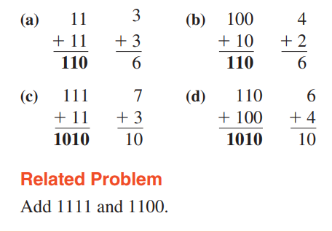

**Compliments**



